Heraldry 101

Introduction

We, in the Realm of Chivalry, have a vision. Every image we have of the middle Ages shares certain things; Knights in shining Armor, Ladies in beautiful dresses, exotic food and entertainment, and heraldry everywhere. On the Knights Shields, waving from the battlements of tall towers, painted on the pages of books and scrolls, sewn on tabards and dresses, and even on horses’ bardings. The medieval lords and ladies proclaimed their presence with their Arms. No tournament or Feast that we hold can evoke the same atmosphere without the same sort of display. This display comprises only a small part of “heraldry”, but this course deals with the basics of that part.

Heraldry, more correctly termed Armory, is a hereditary system of personal recognition, employing symbols (called charges) upon a shield, which developed among the nobles during the middle ages.

Notice that the primary purpose of heraldry is identification. This held, and still holds, true, particularly, on the field of battle, in processions, in the lists of a tournament, or any other gatherings of nobles. The arms identify the person. Their heraldry is their signature. Second, the association of heraldry with noble title and inheritance are inescapable and formed the basic part of medieval social thought. So intimate was this connection, that medieval historians could not imagine famous historical people without Arms, and so invented and cataloged “attributed arms” for everyone from Adam, God, and even Satan. Arms became so important that it became impossible to associate a noble person without them.

In the Realm of Chivalry, the implications of Armory have changed somewhat, but its intent and purpose have not. No longer does heraldry necessarily imply rank. Anyone in the Realm is permitted to register a device. Realm heraldry tends not to be hereditary, and although exception may occur, the vast majority of Arms exist independent of any other.

In order to achieve the atmosphere of our shared vision, it is necessary that our heraldry look medieval. The purpose of this course is to assist the student with designing, submitting, and registering appropriate Arms, as well as acquaint him or her with the fundamentals of medieval heraldry.

Terms in Heraldry

Arms A heraldic device found upon a shield belonging to an individual
social group, or organization that uniquely identifies its owner.

Base The bottom portion of a shield.

Blazon The verbal or written description of Arm, or heraldic device.

Bordure A broad band surrounding a shield.

Charge An animal, beast, monster, symbol, etc. found on a shield or device. Can be an ordinary or sub-ordinary.

Chief When used in reference to a location on a shield, it refers to the top
part of the shield. It can also be a broad band across the top of a
shield.

Coat of Arms The entire achievement of a person’s or group’s heraldic device.
This includes any helmet, mantling, mottos, or supporters that
have been registered with the Arms.

Colour Specific tinctures used in heraldry

Default The location, placement, colour, and etc. that is used if no specific
information is supplied.

Dexter The right side of the shield as viewed by the bearer.

Device For our purposes the terms device, shield, Arms, are interchangeable.

Diapering Enrichments to the field of a shield or to a charge. Purely ornamental, and usually geometric in form.

Diminutives Smaller versions (usually thinner) of ordinaries.

Emblazon The pictorial representation of Arms or heraldic device.

Lines of Partition Treatments of the lines that are used to divide the field of a shield, or how the edges of an ordinary are displayed.

Ordinaries Simple flat bands or geometrical figures of painted colour or metal which are super-imposed on a shield.

Sem’e Sprinkled or strewn with an indiscriminant number of smaller charges.

Sinister The left side of the shield as viewed by the bearer.

Sub-Ordinaries Simple geometric forms such as a Bourder, or an Orle, etc. that are used on a shield

Tincture The colours used in heraldry.

Vair A heraldic representation of squirrel furs.

The Shield

Positions on the shield in heraldry are determined not from the point of view of the onlooker but from that of the bearer of the shield.

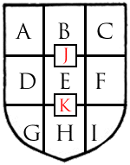

- Dexter Chief D. Dexter G. Dexter Base
- Center Chief J. Honor Point E. Fess Point K. Nombril point H. Center Base
- Sinister Chief F. Sinister I. Sinister Base

Divisions of the Field:

The field of a shield may be divided by a line or lines into two or more parts. The parts being of different colours or metals. The divided field is described as parted per pale, per fess, and so on according to its pattern. Quarterly is a more usual term for a shield divided into four. Gyronny is usually drawn of eight pieces, as the divisions are called. Actually, the term gyronny can be applied to any number of equally spaced divisions greater than four. The partition lines may be simple or ornamental.

Each division of the shield is tinctured. The first mentioned tincture is on the upper side of the dividing line. In the case of “per pale” it is on the dexter side of the line. When divided “quarterly”, the first mentioned is the top dexter and the bottom sinister. When divided ”per saltier”, the first mentioned is in the upper part of the shield and in the base. The second mentioned is the dexter and sinister sides. In “gyronny”, each piece is tinctured alternately. The first mentioned is the top dexter piece between the bend and pale dividing lines.

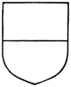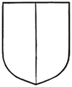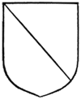
Per Fess Per Pale Per Quarter Per Chevron Per Bend

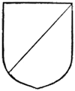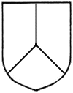
Per Bend Per Saltier Per Pall Per Pall
Sinister Reversed

Varied Fields:

Varied fields are made by further divisions, which always consist of an even number of pieces. For example, “barry”, a number of horizontal lines across the field, “bendy”, a number of diagonal lines across the field, and “paly”, a number of vertical

lines across the field. Crossing lines produces “chequey” which is a combination of “paly” and “barry”. Crossing diagonal lines produces “lozengy” and “fusilly”.

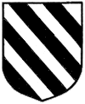

Barry Bendy Paly Chequy Lozengy

Diapering:

charges, d To enrich the plain surface of the field of a shield, and in some cases, that of the ecorations may be applied. This is called diapering. It need not conform to the laws of tincture and it can be executed in any colour or metal. The pattern used is purely ornamental, usually geometrical in character. It must not compete with heraldic tinctures and must not be mistaken for charges (must be very small). Effective diapering can be made with gold patterns on a field of any of the colours, or by painting the ornaments in a different tint than that of the field.

Heraldic Tinctures:

In the Middle Ages, Arms on shields were simple in design and bold in their colours. The choice of colours was of particular importance; the aim was to make the Arms clearly visible at a distance for purposes of identification in combat.

In heraldic usage there are two metals, five colours, and two groups of furs. The Metals, colours, and furs are collectively referred to as tinctures. The metals, which are gold, called “Or” is represented by yellow, and silver called “Argent” is represented by white. The colours are red called “Gules”, blue called “Azure”, green called “Vert”, black called “Sable”, and purple called “Purpure”. There are other colours, however, they were not used in heraldry until later time periods. Objects that are displayed in their natural colour are blazoned as being proper.

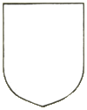
Argent Or


Gules Azure Vert Purpure Sable

The Rule of Tincture Explained

Contrasting colours are visible from a greater distance than colours that are similar. For this reason, it became the general principal not to place a colour on a colour, nor a metal on a metal. There are exceptions to this rule; a party field of metal and colour can have placed upon it a charge of another metal or colour, provided the charge rests on the field as a whole. The rule dies not apply to bordures, nor to a charge that surmounts both the field and another charge.

Charges:

A shield is said to be charged with a device upon it. Although the term usually applies objects rather than ordinaries, the field of a shield and the ordinaries themselves may be charged. That is, may have objects placed upon them. Charges may be used singly or in numbers.

Arrangement and Placement of Charges:

The size, or scale, of the charge in relation to the field is a matter of judgment which is only developed by practice and referring to good examples. A single charge, for example, should comfortly fill the area of whatever shape is chosen. If drawn to large, it will appear cramped. If drawn to small, it will lose its significance.

The disposition of plural charges is indicated in the blazon and these must be correctly placed. Three similar charges are usually blazoned two and one, and this is considered the default position. When there are more than three charges, their disposition must be specified in the blazon. Example: 10 bezants, four, four and three. Counting reads from chief to base. When animals or monsters are the charges no harm is done, indeed the effect is enhanced if they vary in size an outline.

The position of charges may be indicated by the direction of the ordinaries. Objects in a horizontal line across the middle are said to be “in fess”. Across the top of the shield would be blazoned as “in chief”, and so on. This does not mean that the charges must occupy the space of an ordinary, but that they are arranged in that direction.
When a fess or a chevron is between three charges they are placed two above in chief and one below in base. When similar charges number more than three, they are places in groups.

The term seme’, semy, sown with, or powdered is used to describe an indeterminate number of small objects usually distributed equally over the surface of he field, ordinary, or charge.

Dividing Lines:

The lines dividing the shield into parts, or outlining the ordinaries, or other figures placed on the field may be plain or ornamental. A line is plain unless otherwise stated in the blazon. These following are ornamental lines that are commonly used.


Dancett’e Dovetailed Embattled Engrailed

Invected Nebuly Potent’e Raguly

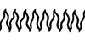
Rayonn’e Wavy Indented Fleury-Counter-Fleury

The Ordinaries:

The simple flat bands or geometrical figures of painted colour or metal superimposed on the field of a shield are called ordinaries. These ordinaries are thought to be related to the structure of medieval shields used in combat, which were made of leather stretched on a foundation of wood and strengthened with bands of metal. The ordinaries divide the shield symmetrically and are of great importance in the satisfactory arrangement of the charges. They are admirably proportioned and displayed in the earlier Coats of Arms.

The proportion of the ordinary to the field varies when the ordinary is alone on the shield, or when between charges, or is itself charged. The width of the chief, fess, and pale should be slightly less than one-third of the shield when neither the field nor the ordinary are charged. The ordinary should occupy a full third when they are charged upon a plain field.

The bend, chevron, cross, and saltier should occupy one-third of charged, one-fifth if uncharged. Charges placed on a bend slope with it unless blazoned otherwise. The chevron has its point in chief unless blazoned as the reverse. It is usually drawn as a right angle, but may vary according to space, the type of shield it is being drawn upon, or the charges being drawn upon it. A charge on the center of a chevron is placed erect, and charges on the sides of a chevron usually do not slope with it. A pile usually issues from the chief, but may do so from either side or base of the shield. Charges on a saltier slope with the limbs unless otherwise blazoned.

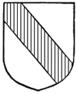
Bend Cross Chevron Saltier Pile

Ordinaries may have straight border lines, or they may be varied using any of the other lines of partition. The character and weight of ordinaries and their charges must be considered when deciding their proportions, and experienced scribes will place them by eye.

The Diminutives:

Ordinaries may occupy one third of the depth or width of the shield. Similar ordinaries are not usually repeated on one shield, that is to say two fesses, or two chevrons, but some of the ordinaries have diminutives. That is to say smaller versions of the original.

Bar The bar is narrower than the fess. Two or more bars may occur
together. Bars must show the field above and below and between
them, to distinguish them from the field known as barry.

Bars Gemelles The diminutive of the bar is the barrulet. When placed in couples

they are referred as bars gemelles. (Twin bars)

Fess Cotised When a barrulet is placed on either side of the fess, the fess is said

to be cotised or doubly cotised.

Pallets Two or more palewise strips are called pallets and these must be
distinguished from paly, as bars are from barry. The endorse
which is narrower than a pallet is usually found in pairs in closing
other charges, thus a pale may be endorsed.

Bendlets Two or more narrow bends on a shield are bendlets and must be
distinguished from bendy. A bend between cotises is called a bend cotised, or if there are two on each side, doubly cotised.

Chevronels Two or more narrow chevrons may be borne on one shield, three
or more are called chevronels. They are placed one above the other unless otherwise specified in the blazon. As with the fess and bend, the chevron may be cotised or doubly cotised, or double close as it may be called.

For a general guide the proportion of the barulet may be a quarter of the width of the bar, the pallet, bendlet, and chevronel half the width of the bar, and the endorse and cotise a quarter width of their ordinaries.

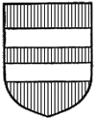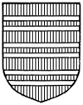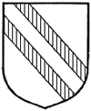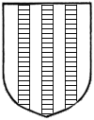
Bars Bard-Gemells Bendlets Chevronels Pallets

The Sub-Ordinaries:

Bordure The bordure or border, may be plain or made with ornamental lines
of partition. It may be parted or charged.

Inescutcheon The inescutcheon may be borne singly or in groups and is often
charged. A single inescutcheon should be appreciably smaller than the area enclosed by a bordure in order to distinguish between them. The inescutcheon of pretence usually smaller in proportion than a single inescutcheon borne as a charge.

Orle The orle is an Inescutcheon with the center cut out leaving only a
narrow bordure. Charges placed along the line of an orle are said to be “in orle”.

Tressure The tressure is a narrow bordure inside of the shield, usually
double, and enriched with fleur-de-lis and sometimes with other devises. The space between the double tressure is voided.

Flaunches Flaunches are always in pairs, they consist of curved lines from the
top corners of the shield to the base.

Canton The canton is a small rectangle in the dexter chief occupying less
than one quarter of the shield. The canton is often charged. When a canton is carried with a bordure the bordure stops where it touches both, being on the same plane, unless the bordure has been added later as a difference.

Gyron The gryon is the lower half of a canton or quarter, which has been
divided by a diagonal line from the dexter or sinister chief.

Lozenge The lozenge is a diamond shape.

Fusil The fusil is similar to the lozenge, but is a narrower shape.

Mascle The mascle is a voided lozenge.

Rustre The rustre is a lozenge pierced with a round hole.

Fret The fret is one bendlet dexter and one sinister interlaces with a
mascle.

Fretty Consists of bendlets both sinister and dexter interlaced. They
cover the entire field.

Annulet The annulet is a plain ring of either a color or a metal. They may
appear singly or in groups and may be interlaced.

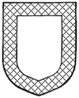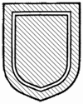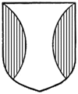
Borduer Escutcheon Orel Tressure Flaunches


Canton Gyron Lozenge Fusil Mascle


Rustre Fret Fretty Annulet

Roundels

Roundels (disks) are sometimes blazoned by names that imply their color.
Tincture |  |  |  | Color |  |  |  | Name |  |  |  | Represents
Argent |  |  |  | White/Silver |  |  |  | Plate |  |  |  | a silver coin
Azure |  |  |  | Blue |  |  |  | Hurt |  |  |  | a hurtleberry or a bruise
Gules |  |  |  | Red |  |  |  | Torteau |  |  |  | a cake, tart or loaf of bread
Or |  |  |  | Yellow/Gold |  |  |  | Bezant |  |  |  | a gold coin
Purpure |  |  |  | Purple |  |  |  | Golpe |  |  |  | a wound or a grape
Sable |  |  |  | Black |  |  |  | Pellet/Ogress |  |  |  | a cannon shot
Vert |  |  |  | Green |  |  |  | Pomme |  |  |  | an apple or an olive
Wavy bands of  Argent & Azure |  |  |  | White & Blue |  |  |  | Fountain |  |  |  | a body of water

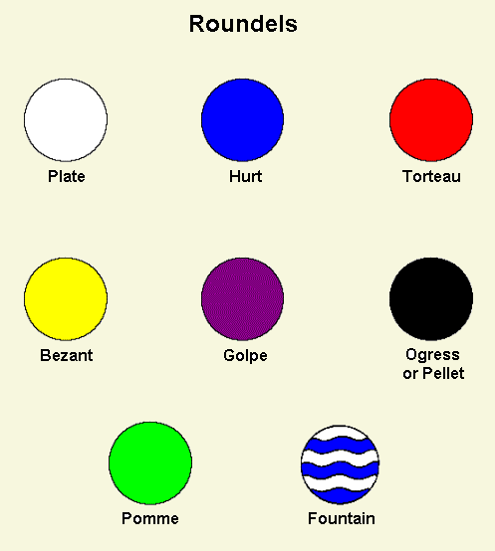

Gouttes

Gouttes (drops) are sometimes blazoned by names that imply their color.
Tincture |  |  |  | Color |  |  |  | Name |  |  |  | Represents
Argent |  |  |  | White/Silver |  |  |  | Goutte d'eau |  |  |  | a drop of water
Azure |  |  |  | Blue |  |  |  | Goutte des larmes |  |  |  | a tear drop
Gules |  |  |  | Red |  |  |  | Goutte de sang |  |  |  | a drop of blood
Or |  |  |  | Yellow/Gold |  |  |  | Goutte d'Or |  |  |  | a drop of gold
Purpure |  |  |  | Purple |  |  |  | Goutte de pourpre |  |  |  | a drop of wine
Sable |  |  |  | Black |  |  |  | Goutte de poix |  |  |  | a drop of pitch/tar
Vert |  |  |  | Green |  |  |  | Goutte d'huile or  Goutte d'olive |  |  |  | a drop of olive oil
What some gouttes represent has varied over time.
The plural of goutte is goutty (ie: goutty d'eau).

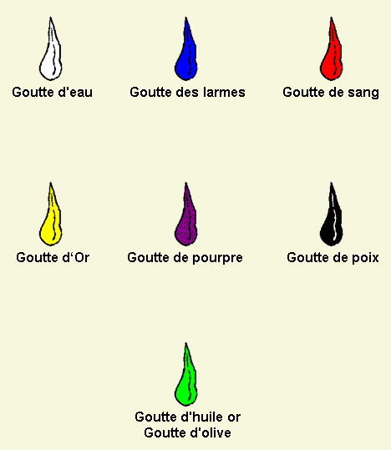

The Blazon (or I have a picture, how do I describe it.)

To describe a coat of arms in words is to blazon it.

When a contestant entered the lists at a tournament in the middle ages, his presence was announced by the sound of a trumpet, after which the heralds declared his insignia, or in other words, blazoned his arms.

The language of early blazons was either French or Latin. Later they became anglicized, except for a few technical terms. Gradually blazons became extremely complicated with the addition of elaborate rules and at times became almost unintelligible. In the Realm of Chivalry, the collage of arms is making an attempt to simplify both the composition and blazon of arms.

It is important to understand that a blazon is merely a convenience for the heralds and scribes that must deal with such matters. When arms are registered, it is the picture that is registered, not the blazon. The intention of the blazon is not to allow two persons to depict a coat of arms exactly similar in minute detail, but rather to enable each other to render it correctly in all essentials so that there is no doubt as to what is really intended.

A blazon contains only the heraldically relevant information, omitting details that are present by default. The coloration of a beast’s eyes, feet, claws, etc. are left to the discretion of the artist rendering the emblazon. The only exception to this is if the person bearing the arms wishes to elaborate on the details. Essentially the artist’s choice of proportion, style, and shade of colors can also change the appearance of a device without deviating from the blazon. It is better by far to blazon only the important features of a device and leave the minute details to the artists and scribes.

There is a basic grammar, or guideline, for blazoning a device.

The field description.

This structure lists the features of a device in order of their visual importance. If it is a simple field, or a field with a seme, the first word in a blazon is the tincture of the field. If the field is divided, the type of division is named first, followed by the tinctures of the field ordered from chief to base, and from dexter to sinister. If one part of the field is further divided or has a seme, then a full description of that part is given as its tincture.

The primary charge group in a device is a major charge or set of charges. If the device contains one or more ordinaries (other than a chief or bordure), they are always the primary charge group. The description of the group is constructed as follows:

Number of charges, identity of the charge, orientation of each charge,
arrangement of the charge in the group, tincture of the charges.

An exception to this rule is when a device contains two or more of a diminutive of an ordinary, with a group of charges between them, those other charges may be blazoned as the primary charge.

Each charge group description will include a number, identity, and tincture. Orientation and arrangement clauses need only be included if either is other than the default. The identity of the charge includes positions for animals, number of points on a mullet, and lines of partition for ordinaries. The Tincture of a charge is described exactly as a field, with tinctures, divisions, and seme.

In Realm of Chivalry heraldry, the tincture does not always follow immediately after the charge. If a series of charges in a blazon share a tincture, that tincture is named only once after the last such charge.

The orientation of each charge in the group is described as being relative to the field. Usually, the charge has an obvious top (like a person or monster’s head, the point of a sword, the leaves of a tree, etc.). The top generally points to the chief by default. An exception is that when a charge lies on a bend, bend sinister, or chevron, they align along the ordinary by default. In general, the top and front of a charge face to chief and dexter unless otherwise specified. Any other orientation must be mentioned in the blazon. In Realm of Chivalry heraldry, “…wise” always refers to the orientation of each charge in a group while “in…” always refers to the arrangement of the group of charges.

Between the charge group and the blazon are placed position specifiers that locate the group of charges relative to the field or to the previously mentioned charges. In the examples below the position identifier is underlined.

Per pale sable and or, a fess embattled and counter-embattled between
three water-bougets countercharged.

Paly sable and argent, on a fess vert, three acorns argent.

As stated earlier, the chief or bordure is an exception to the rule that an ordinary is always the primary charge. This is because they do not change the appearance of the main part of the shield. A chief or bordure, and any charges on it, can be considered added to a design.

